TEMPLATE LAPORAN PRAKTIKUM WEB

Nama : Muhammad Rifki Widadi Kelas : CS18

NIM : 105218005

1. Source code

Github: https://github.com/mrifkiw/pw-praktikum-2.git

* 1. HTML

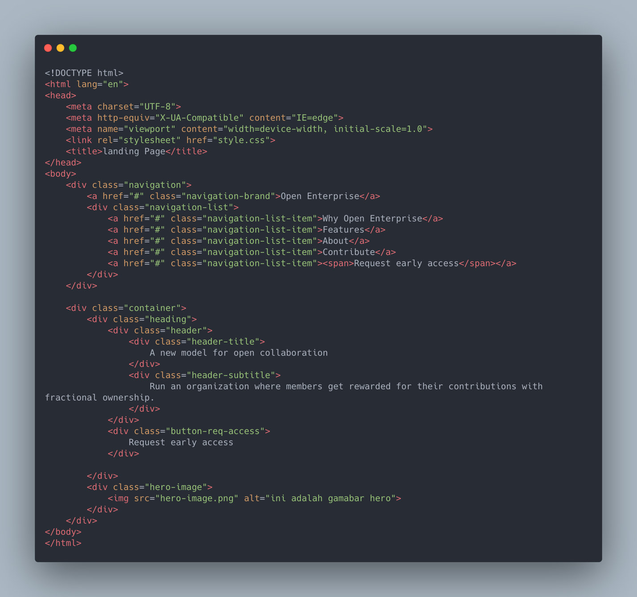

* 1. CSS

1. Hasil
   1. Desain  
      https://www.figma.com/community/file/839442424194047238  
      A screenshot of a computer

      Description automatically generated with medium confidence
   2. Coding  
      Graphical user interface, website

      Description automatically generated